# 

COMP30022 Semester 2, 2020

# **ePortfolio**

# **The Tech Pirates**

# Auren Denasha-Andrew, Miles Lamberti, Girish Mohan Madnani, Abdiaziz Farah, William Lord

[Deployed Web App](https://tech-pirates-portfolio-web-app.web.app/) : <https://tech-pirates-portfolio-web-app.web.app/>

[Github Repository](https://github.com/mileslamberti/ePortfolio) **:** [**https://github.com/mileslamberti/ePortfolio**](https://github.com/mileslamberti/ePortfolio)

# **Requirements**

**Overview**

Our client wished to provide customers with an online portfolio web app, an ePortfolio, which proudly displays their projects. Customer’s projects are comprised of collections of files (which have a wide range of file types) and need to be logically sorted and displayed. Projects must be able to be shared with other people, therefore there must be support for downloading files. Users of the website must be able to have their own personal account which contains their projects as well as some information about themselves. Additionally, users must be able to configure the visibility of their profiles so that they can hide their profile and projects from others. The requirements of the ePortfolio can be partitioned into the following two categories:

**Functional Requirements**

* Register a new account
* Log into a preexisting account
* Display and edit autobiographical information
* Create projects
* Upload files to projects
* Share projects (including downloading files) and view profiles
* Configure privacy to hide or show profile

**Non-Functional Requirements**

* Responsive
* User friendly
* Visually appealing (a thought out design)
* Security of sensitive information
* Reliable

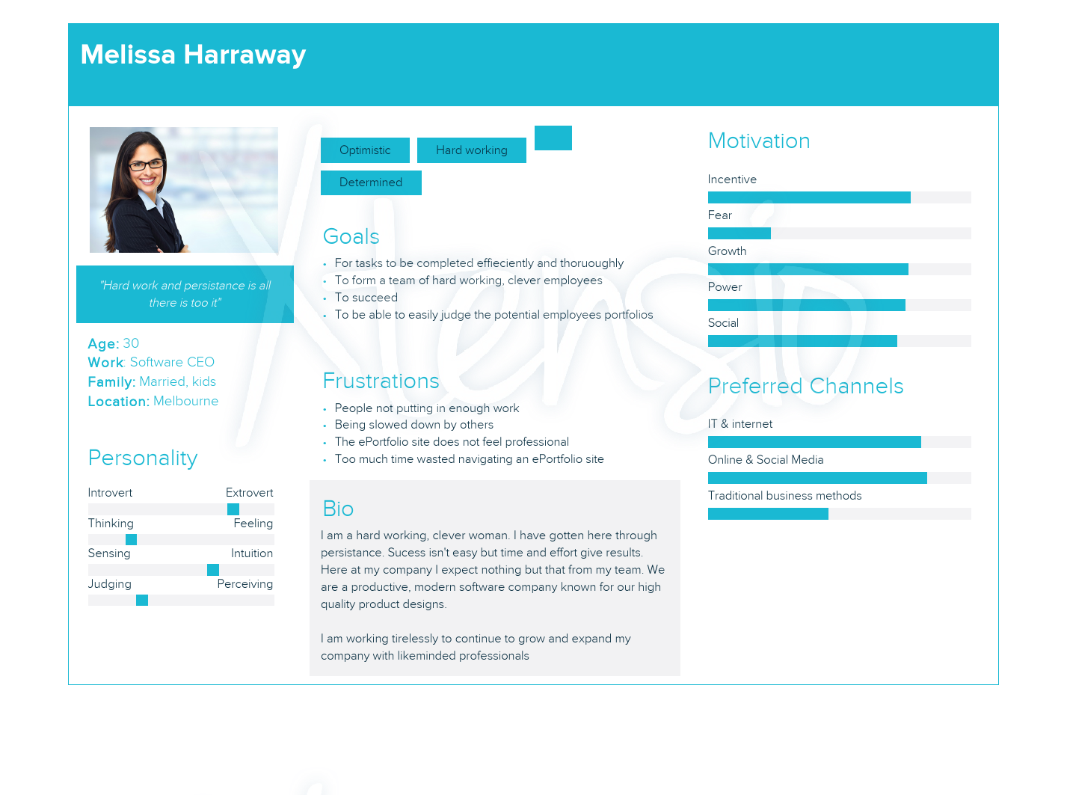

**User Personas**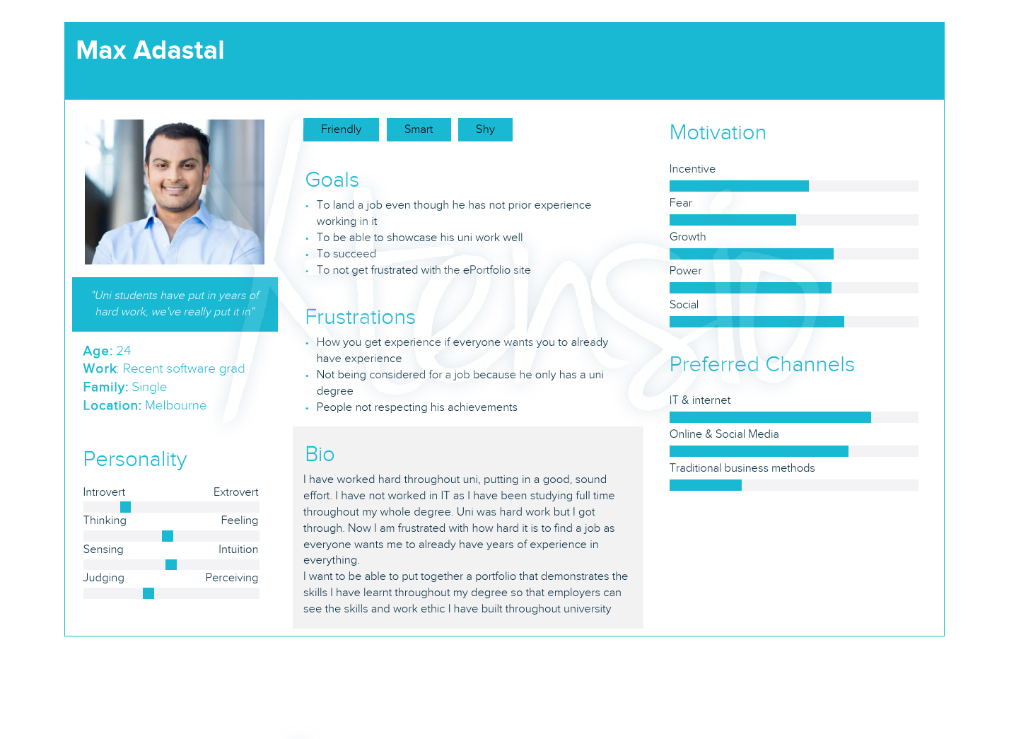

**User Stories**

|  |  |  |  |  |
| --- | --- | --- | --- | --- |
| ID | As a  <Role> | I want to  <Do something> | So that  <Achieve some goals> | Priority |
| 1 | Max (Uni-Grad) | Upload uni projects | Work can be showcased professionally | HIGH |
| 2 | Max (Uni-Grad) | Add past experience | Employers can see what I have done and achieved | HIGH |
| 3 | Max (Uni-Grad) | Control access to ePortfolio | Privacy can be controlled | MEDIUM |
| 4 | Max (Uni-Grad) | Create and edit an “about me” | I can explain and promote who I am | MEDIUM |
| 5 | Max (Uni-Grad) | Register | I can use the ePortfolio | HIGH |
| 6 | Max (Uni-Grad) | Login/logout | I can access my profile | HIGH |
| 7 | Max (Uni-Grad) | Update and organise a project | I can showcase my work in a professional and impressive manner | HIGH |
| 8 | Melissa (Employer) | View a user’s ePortfolio | I can decide who to hire | HIGH |
| 9 | Melissa (Employer) | Contact owner of ePortfolio | I can ask them questions or hire them | MEDIUM |
| 10 | Melissa (Employer) | Easily interact with website | I do not get frustrated and waste time | HIGH |
| 11 | Melissa (Employer) | Browse search and view registered users | I can find potential employees | MEDIUM |
| 12 | Software developer | Ensure code is understandable | It can be maintained | MEDIUM |
| 13 | Software developer | Easily modify/extend the system | I can be more productive | MEDIUM |
| 14 | Client | The system to be reliable | It is available and usable all of the time | HIGH |
| 15 | Client | The system to be complete | Requirements are met | HIGH |
| 16 | Client | The system is secure | Future users can feel secure in using the site | HIGH |

# **Implemented Features**

All of the requested requirements of the client were implemented in the final product, as well as some additional functionality that we believed would enhance the users experience and improve the ePortfolio. These additional features are indicated with an asterix. The implemented features can be split into three categories, in which the Profile category encompasses all features related to the users profile, including account management functionality. The Project category refers to all functionality that relates to how projects are displayed, edited and shared. Finally, the General category contains all features that relate to the general use of the web app.

**Profile**

* User registration, login and logout.
* Autobiographical information (about me, contact details)
* Multiple experiences and education history can be added
* User display picture
* Profile tags (used to display key skills)*
* Unique path for each user so that they can share their profile
* The option to toggle between public and private profile visibility

**Project**

* Upload files
* Download files
* Share projects consisting of files
* Add descriptive information to projects (title, subtitle, description)
* Organise files within a project into cards, which can be dragged and dropped into a desired order*
* Option for user to upload or select a default image for a project card*
* Add descriptive information to cards (title, subtitle, description)

**General**

* A home page, including a slideshow
* Help buttons to explain functionality*
* A profiles page, which displays all public users of the ePortfolio, whose profiles can be visited*
* Search functionality within the profiles page to find specific users (can search via handle, display name or skill tag)*
* Security of users accounts ensured via system of unique tokens for user sessions (sensitive information, or editing of any aspect of profile or project requires authentication)
* Encryption of user’s password. Passwords are stored encrypted such that even a database manager does not have access to their password.

# **Testing**

Testing throughout the development process was done at the end of each sprint, to ensure that new functionality works correctly and that its introduction does not interfere with any pre-existing functionality. Note, no testing was completed after the first sprint as the implemented features were very sparse at that point, and not useful to test.

**Completed after second sprint:**

Task: Register User:

|  |  |  |  |
| --- | --- | --- | --- |
| **Problem** | **Method of testing** | **Expected result** | **Result** |
| Register account | Visit the register pages and input details | After registering, the correct inputted users details appear in firestore | Passed |
| Register an account with the same email or username | Input the same email or username as a previous user | Should return an error | Passed |

Task: Login User:

|  |  |  |  |
| --- | --- | --- | --- |
| **Problem** | **Method of testing** | **Expected result** | **Result** |
| Login to account | Visit the Login register page and input details | Checks for the users username in the backend and routes to the users profile | Passed |
| Wrong Details | Input wrong detail in the login columns | Should return an error | Passed |

Task: Home Page:

|  |  |  |  |
| --- | --- | --- | --- |
| **Problem** | **Method of testing** | **Expected result** | **Result** |
| Homepage button | Visit the home page before login and after login | The button should route to the register page before login and user profile after login | Passed |

Task: User Profile:

|  |  |  |  |
| --- | --- | --- | --- |
| **Problem** | **Method of testing** | **Expected result** | **Result** |
| Display picture upload and change | Visit the logged users profile page and edit display | Upload and picture and change it | Passed |
| Edit button | Clicking edit button to edit component and viewing them after submitting | Changes the details to the new edited details and also updates the firebase backend | Passed |

Task: Projects:

|  |  |  |  |
| --- | --- | --- | --- |
| **Problem** | **Method of testing** | **Expected result** | **Result** |
| Upload project | Clicking the upload project button from the navbar then creating a project | Project is created and visible on the database | Passed |

**Completed after third sprint:**

Task: View User:

|  |  |  |  |
| --- | --- | --- | --- |
| **Problem** | **Method of testing** | **Expected result** | **Result** |
| View a user that you are not logged in as | Visit “/otherUserHandle” | Correct user details are displayed with all edit buttons hidden | Passed |

Task: Privacy Settings:

|  |  |  |  |
| --- | --- | --- | --- |
| **Problem** | **Method of testing** | **Expected result** | **Result** |
| Change the privacy configuration | Change to private and checking if the private user preview can be displayed by visiting “/userhandle” | Should not be able to view their page | Passed |

Task: Profiles Page:

|  |  |  |  |
| --- | --- | --- | --- |
| **Problem** | **Method of testing** | **Expected result** | **Result** |
| Profile displayed after user registered | Visit the profile page and look for the user that had just registered | The user profile display name, username, display Picture and tags show | Passed |
| Search by username | Using the search bar to look for a profile | Show the user profile whose username was searched | Passed |
| Search by display name | Using the search bar to look for a profile | Show the user profile whose display name was searched | Passed |
| Search by skills | Using the search bar to look for profiles | Show profiles who has the skills that are searched | Passed |
| Visit Profile button | Clicking the button to visit a random user's profile page | Route to the users profile page | Passed |

Task: User Profile:

|  |  |  |  |
| --- | --- | --- | --- |
| Can add/edit information in each component (about me, user info, education, skills and experience | Add and edit each component in profile then re-render page to see changes | Details added, once submitted are displayed are page is refreshed | About me: Passed  Contact info: Passed  Display Picture: Passed  Education: Passed  Experience: Passed |

Task: Projects:

|  |  |  |  |
| --- | --- | --- | --- |
| Upload a project | Login in and visit the “upload project” page.  Enter a title and description. Select a collection of files and click submit.  Add a card, inputting the relevant information  Edit card and check the “files to associate with card” | Once submitted, the user is taken to “/projectID”  The correct details are displayed.  Editing a card shows the uploaded files. | Passed |
| Edit a project | Edit a project’s title and description, submit and after submission, refresh page | The updated project information is displayed | Passed |
| Delete a project | Click the delete button on a project then view user’s profile as well as revisit direct project link | The project can not be seen and visiting the old url shows nothing | Passed |
| Add a project card | Click add project card.  Enter card information  Submit and then reload after submission | Correct information entered in card is displayed | Passed |
| Edit project card | Edit a cards information, submit and after submission, refresh page | Updated information entered in card is displayed | Passed |
| Assign files to card | Click the edit button on a project card. Choose files to assign to card  Submit and then reload | Assigned files can be viewed by clicked the drop down button on a card | Passed |
| Choose a image for a project card | Click the edit button on a project card. Upload an image. Submit and reload | Uploaded image is shown on card | Passed |
| Delete a project card | Click delete button on a project card and refresh page | Project card is no longer seen and files assigned to this card are now able to be assigned to other cards | Passed |
| Rearrange project cards | Drag and drop cards to rearrange. Refresh page afterwards | After page refresh, cards are in the updated order | Passed |
| Upload files to an existing project | Click “add files to project”.  Upload files.  Edit a card and check “files to associate with card” | Uploaded files can be seen in the“files to associate with card” drop down | Passed |
| Download project files | Click the download button next to a file | File downloads to computer or opens in new tab | Passed |

# **Deployment Pipeline**

1. A new request is reviewed by and approved by another team member who runs user tests on added/updated features.
2. The request is merged into master
3. In the console run “npm build” followed by “firebase deploy”

# **Strengths of the ePortfolio**

We believe that the project section is implemented really well and has a lot of useful functionality to enable a user to display, share and download their projects. It is not limited to any particular file types which allows users to show off any sort of project that they’re proud of, whether it is a collection of photos, source code or even videos. Within the edit project functionality, the ordering of project cards via ‘drag-and-drop’ is a particularly nice feature as it is intuitive and allows greater user interaction with the web app.

We are proud of the emphasis that we placed on security throughout the development of the ePortfolio. The privacy and security aspects of the project is another key area which we think is quite strong. The implementation of tokens to verify authentication gives a solid basis of security throughout the project which is then built on with the application of backend routes, which limits access to sensitive areas of user’s data. Further, the privacy functionality of user’s profiles allows users to limit whether anyone can see their profile, which is useful if they want their ePortfolio to serve a more personal versus public role.

We are pleased to show off the ‘/profilespage’ functionality of the web app, which we implemented to extend from the client’s initial requirements. It displays all of the users of the ePortfolio, showing some brief information including their ‘tags’, which is used to display particular skills that they have. We believe that the profiles page can give a newcomer to the website a quick and useful insight into the functionality and strengths of our web app. Further, this system of tags allows a user of the ePortfolio to search from the profiles page to display users who have certain skill tags, allowing, for example, all users who are proficient in Javascript to be displayed and then have their profile visited. This can be extended to the use case of a potential employer, who is looking to recruit people with certain skills. From this perspective, it is clear that the profiles page and search functionality greatly extends the scope of possible uses for the ePortfolio and we are proud to be able to present it.